**Project Design Phase-I**

**Solution Architecture**

|  |  |
| --- | --- |
| Date | 19 September 2022 |
| Team ID | PNT2022TMID21861 |
| Project Name | Project - Car Resale Value Prediction |
| Maximum Marks | 4 Marks |

**Solution Architecture:**

The car resale value prediction shall be performed using several machine learning techniques. These 4 machine learning techniques are about to be used in the car resale value prediction process.

* Multiple Linear Regression Analysis
* K-Nearest Neighbours Algorithm
* Decision Trees
* Naïve Bayes classification
* These 4 machine learning techniques shall be used in the process and the predictive model shall be produced from ‘N’ number of sample data(learning process).
* The predictive model shall be tested with ‘N’ number of inputs to obtain a successful predictive model.
* Once a successive predictive model being produced,the new data obtained from the users shall be used to predict the price of the resale car.

**Solution Architecture Diagram:**

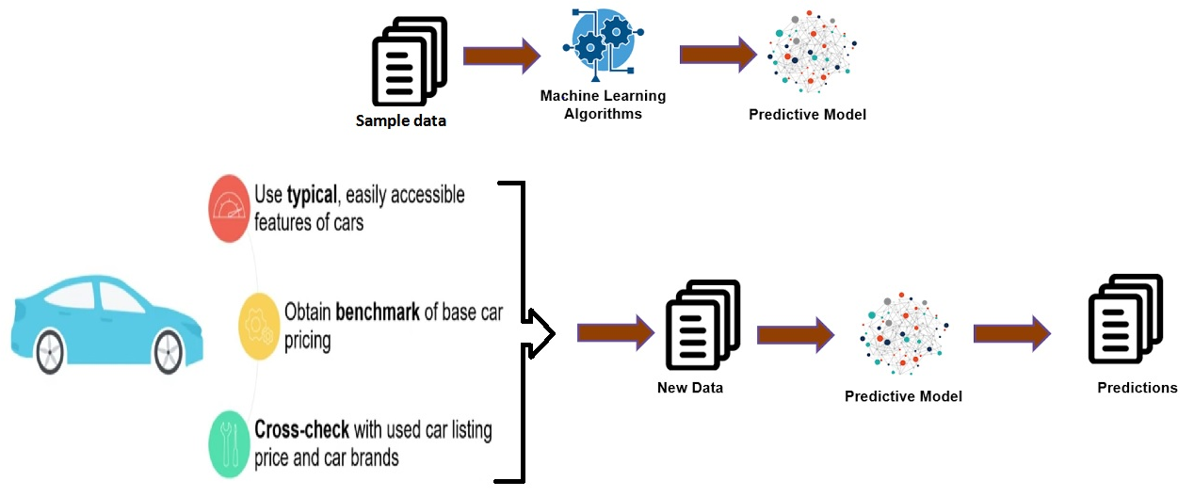

Figure 1: Architecture and data flow of the car resale value preddiction system